Project 1

Gage Farmer - ECE 3561
February 23rd, 2024

Solutions

Problem 1

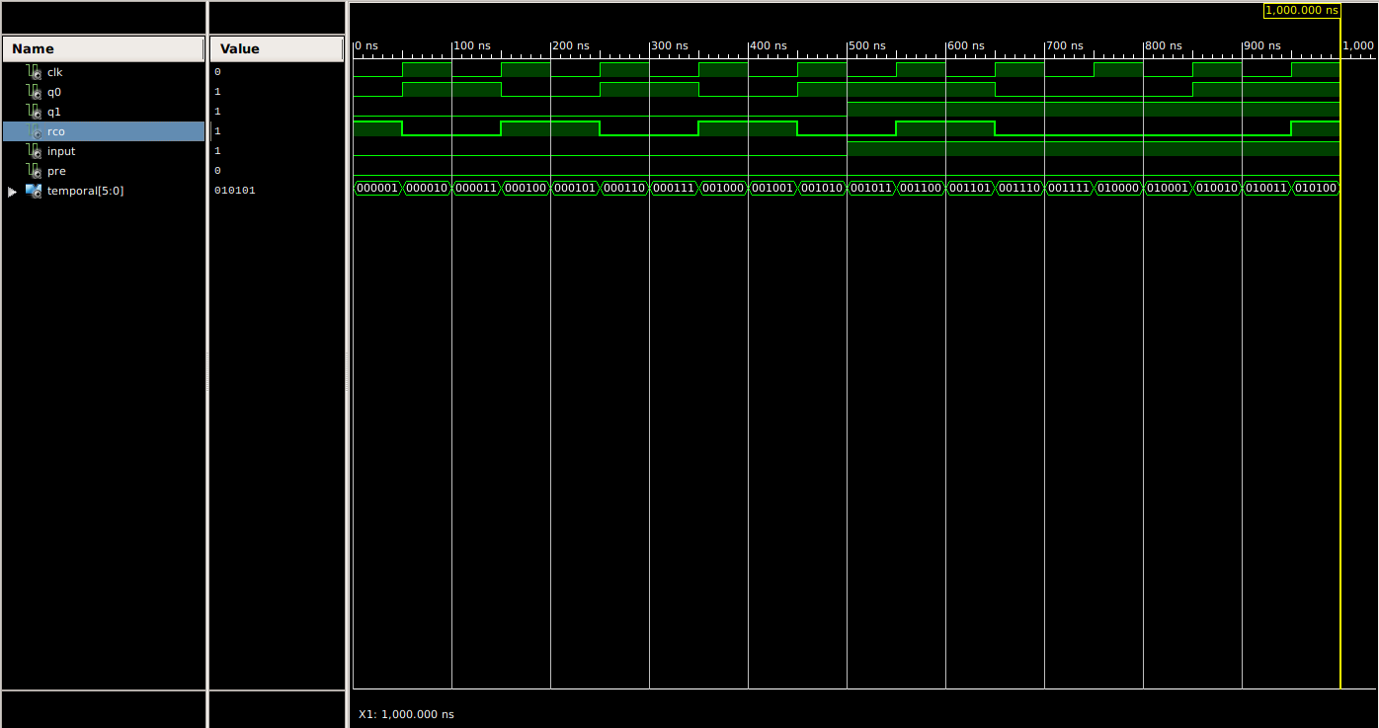
Based on the timing chart above, the circuit appears to be a pulse width extender with toggle using INPUT, and Q0 as the output pulse. PRE acts as a reset input, and when PRE = 1, it sets Q0 and Q1 to 1 as well. RCO appears to act as an XNOR of Q0 and Q1, only outputting 1 when they are the same.

Problem 2

The following graphs were based off of the interpretation that “reverse” operation meant that the inputs would be inverted. The following adjustment did solve this problem.

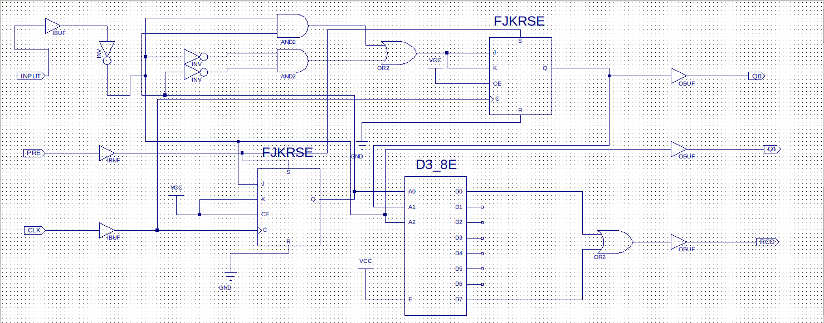
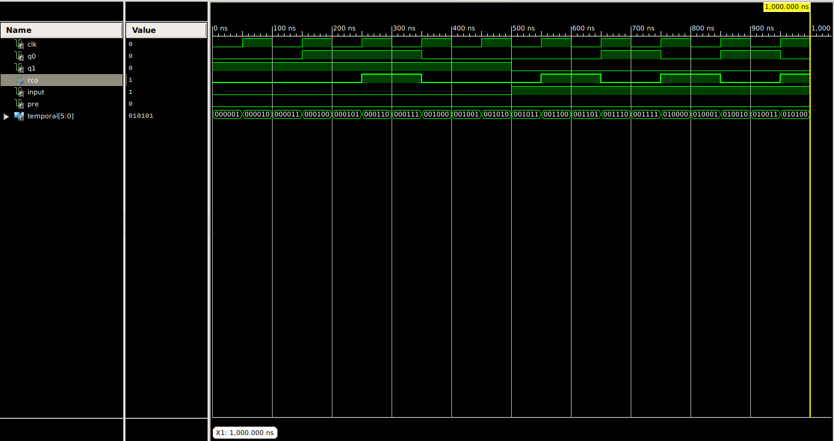

Problem 3

This is a Mealy machine since the INPUT signal runs directly into the output Q1. We do not need to know current states in order to know the value of Q1. Attached below are the State Table and State Diagram.

INPUT | PRE | J2 | S2 | Q2 | AND1 | AND2 | OR1 | S3 | Q0 | Q1
0 | 0 | 0 | 0 | 0 | 0 | 1 | 1 | 1 | 1 | 0
0 | 1 | 0 | 1 | 1 | 0 | 0 | 0 | 0 | Stay | 0
1 | 0 | 1 | 0 | Toggle | 0 | 0 | 0 | 0 | Stay | 1
1 | 1 | 1 | 1 | 1 | 1 | 0 | 1 | 0 | Toggle | 1

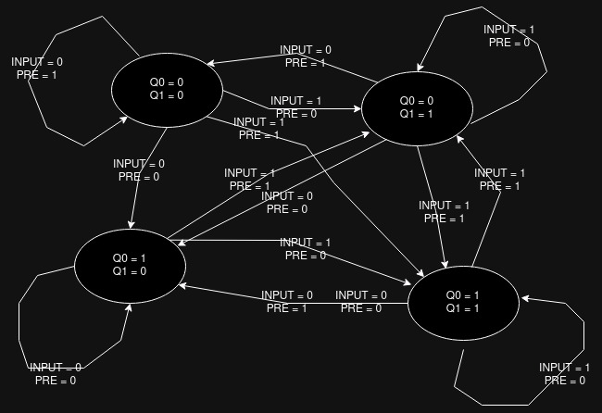

Problem 4

The maximum clock frequency of the circuit according to the timing report is 100MHz. Attached below is the timing report.

